Mothers and Daughters in the African Diaspora
English 211: Women and Literature

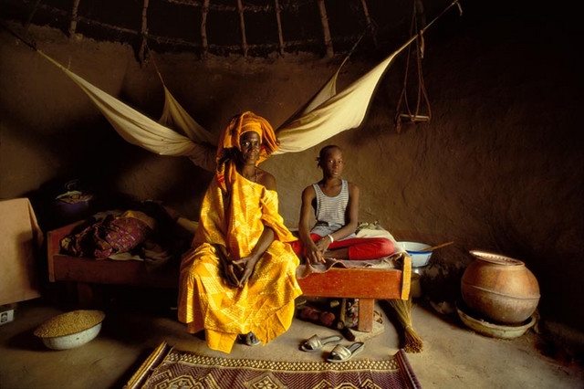

Required texts:
Danticat, Edwidge. Breath, Eyes, Memory.
Jones, Gayl. CorRegidora.
Kincaid, Jamaica. Annie John.
Marshall, Paule. Brown Girl, Brownstone.
Morrison, Toni. Sula.
Naylor, Gloria. Bailey’s Café.
Naylor, Gloria. The Women of Brewster Place

**All books are on two-hour reserve in the library.

Course Overview:
This course will examine the position of mother and daughter figures within the literature of the African Diaspora. In addition, we will examine the mother-daughter relationship and its effects on each participant. We will question the effects of the Black community on that relationship and in turn how that relationship affects the Black community. What are the particular pressures on this relationship? What role does the legacy of slavery play in determining the structure of it? Ultimately we will determine and identify the multi-faceted aspects of Black mothers and their daughters.

Reading and Assignment Schedule
(subject to change)
Week 1
9/1 Introduction

Week 2
9/4- “In Search of our Mother’s Gardens” and “Everyday Use”
9/6 The Women of Brewster Place, “Dawn” and “Mattie Micheal”
9/9 The Women of Brewster Place, “Etta Mae Johnson”

Week 3
9/11 The Women of Brewster Place, “Kiswana Browne”
9/13 “Warrior Marks” (film)
9/15 Class Cancelled

Week 4
9/18 The Women of Brewster Place, “Luciella Louise Turner” and “Cora Lee”
9/20 The Women of Brewster Place, “The Two”
9/22 The Women of Brewster Place, “The Block Party”, “Dusk” and “Dream Deferral, and “Closure in The Women of Brewster Place” (handout)

Week 5
9/25 Bailey’s Café, “Mood Indigo”
9/27 Bailey’s Café, “Eve’s Song” & “Mary (Take One)”
9/29 Class Cancelled Bailey’s Café, “Jesse Bell” & “Mary (Take Two)”

Week 6
10/2 Annie John, Chapters 1 & 2
10/4 Annie John, Chapters 3 & 4 essay due (deadline to drop class)
10/6 Annie John, Chapters 5 & 6
Week 7
10/9 Annie John, Chapters 7 & 8
10/11 Brown Girl Brownstones, p 1 – 49
10/13 Brown Girl Brownstones, p 51 - 92

Week 8
10/16- fall break
10/18 Brown Girl Brownstones, p 92 – 133
10/20 Brown Girl Brownstones, p 134 – 186

Week 9
10/23- Brown Girl Brownstones, p 189 – 240
10/25Brown Girl Brownstones, p 241 – 280
10/27 Guest Speaker: Dr. Yvonne Seon, Allegheny Alumna and Director of the Bolinga Cultural Center
Brown Girl Brownstones, p 280 – 324 and “Paule Marshall’s Brown Girl, Brownstones: Reconciling Ethnicity and Individualism” (handout)

Week 10
10/30 Midterm
11/1 Midterm
11/3 Sula, Intro - 1920

Week 11
11/6 Sula, 1921 – 1927
11/8 Sula, 1937 & 1939
11/10 Sula, 1940 & 1941

Week 12
11/13 CoRregidora, p 1 – 46
11/15 CoRregidora, p 46 - 91
11/17 CoRregidora, p 92 - 132

Week 13
11/20 CoRregidora, p 133 – end
11/22 – thanksgiving
11/24 – thanksgiving

Week 14
11/27 Breath, Eyes, Memory, Chapters 1 – 6
11/28 Breath, Eyes, Memory, Chapters 7 – 12
12/1 Breath, Eyes, Memory, Chapters 13- 20

Week 15
12/4 Breath, Eyes, Memory, Chapters 21- 28
12/6 Breath, Eyes, Memory, Chapters 29- end
12/9 TBA

Week 16
12/11 Wrap Up
12/13 Take home final due

