ENGLISH 320: The Harlem Renaissance
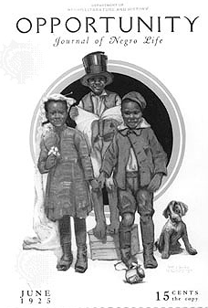
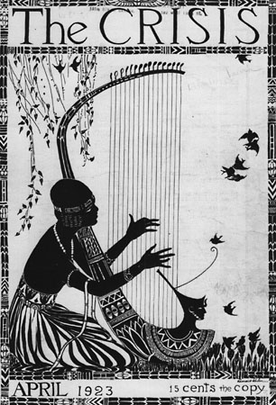
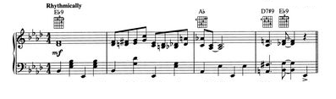

Required Texts:
Hacker, Diane. A Writers Reference.
Professor: Dr. A. Lockridge
Office: Merion Hall 181
Office hours: T/Th- 1:30- 3:30pm and W- 4:00- 6:00pm
Email: aisha.lockridge@sju.edu
Lanhan, Richard. Revising Prose. 5th Edition.
Larsen, Nella. Passing.
Lewis, David Levering. When Harlem was in Vogue.
McKay, Claude. Home to Harlem.
Thurman, Wallace. Infants of the Spring.

Course Description:
The Harlem Renaissance refers generally to an important artistic and sociocultural moment in world history during which Black writers, musicians, and artists of the 1920s and early 1930s produced a body of work remarkable for its breadth and complexity of themes. This course will survey that creative explosion against the backdrop of the political, economic, and social history of the period. Through our readings, we will explore the genesis and meaning of this exciting moment in cultural history, attempting to come to a deeper understanding of what compelled the movement and why the legacies of the Harlem Renaissance continue to influence African American literature and culture. Likely authors will include: Alain Locke, Langston Hughes, Zora Neale Hurston, Countee Cullen, Nella Larsen, and others.

Diversity Objectives:
- Students will understand the complex, dynamic, and dialectical nature of American and African American culture and the political, historical and economic conditions that shaped the Harlem Renaissance.
- Students will investigate patterns of oppression and resistance in African American communities.
- Students will develop understandings about the experiences and contributions (political, social, economic, etc.) of African Americans before and during the Harlem Renaissance (1890- 1940).

Writing Objectives:
- Students will learn invention strategies, consider and apply diverse organizational options, and reflect on stylistic choices in developing a series of writing projects.
- Through analyzing texts and practicing their own writing, students will improve analytical and critical and/or creative writing skills.
- Through classroom instruction and feedback on their work, students will learn the writing conventions of the discipline.
- Through participating in the drafting process, students will learn the techniques of effective revision.

Assessment of Knowledge Acquisition:
- Class Participation/discussion questions 10%
- Critical Essays 50%
- Blog Entries 20%
- Reading Quizzes 10%
- Take Home Final 10%

Assignment & Reading Schedule
(Subject to change at professor’s discretion)

Tu 1/15 Introduction/ “Harlem”
TH 1/17 “The New Negro”( PHRR) and “On Being Young, a Woman and Colored” (BB)

Tu 1/22 “The Double Task of Negro Womanhood”(PHRR) and “I Too” (PHRR)
TH 1/24 Passing, Part I

Tu 1/29 Passing, Part II and III
TH 1/31 Passing, III

Tu 2/5 Revising Prose, Chapter 1 and Writing Workshop
TH 2/7 Home to Harlem, Chapters I – IV

Tu 2/12 Home to Harlem, Chapters V – VII
TH 2/14 Home to Harlem, Chapters VIII – XIII

Tu 2/19 Home to Harlem, Chapters XIV – end
TH 2/21 “Weary Blues”/ “Rejuvenation Through Joy”, CP

Tu 2/26 Revising Prose, Chapter 2 and Writing Workshop
TH 2/28 Against the Odds: Artists of the Harlem Renaissance (in-class documentary film)
Tu 3/5 Spring Break
TH 3/7 Spring Break

Tu 3/12 “Southern Road”(PHRR), “Weary Blues”( PHRR), and “White House”( PHRR)
TH 3/14 “Criteria of Negro Art” (PHRR) and “Negro Artist and the Racial Mountain”(PHRR)

Tu 3/19 “Negro Art Hokum” (PHRR) and “Yet Do I Marvel”(PHRR)and
TH 3/21 Infants of the Spring

Tu 3/26 Infants of the Spring
TH 3/28 Infants of the Spring

Tu 4/2 Infants of the Spring
TH 4/4 Infants of the Spring

Tu 4/9 Brother to Brother (in-class film)
TH 4/11 Brother to Brother (in-class film)

Tu 4/16 “When the Negro Was in Negro”(PHRR), “Harlem Literati”(PHRR), “Parties”(PHRR)
TH 4/18 Revising Prose, Chapter 3 & 4 and Writing Workshop: Draft of essay #3 due in class

Tu 4/23 “Sweat”(BB), “How it Feels to be Colored Me”(BB),
Essay #3 due to Blackboard
TH 4/25 When Harlem was in Vogue, Chapter “The Fall of the Manor”

